**WebRTC**

**Advantages**

* Completely free for commercial and private use.
* Can be used for video, audio, messaging and sending media.
* Open source code, supported by peer to peer technology. Supported by many browsers (Chrome, Safari, Firefox) and if not can add extension webrtc4all.
* Good sound quality using G.711 and Opus codex for transferring audio.
* Compared with Flash, WebRTC has a lot better browser security and stability against external attacks.
* Has always on voice and video encryption using the Secure Real-time Transport Protocol (SRTP) for encryption and authentication on both the voice and video. Which prevents eavesdropping and recording of the voice and video calls. Data streams are encrypted using Datagram Transport Layer Security (DTLS).
* WebRTC protocols do a huge amount of work in improving echo cancellation, dynamic jitter buffering, image cleaning, noise reduction and suppression, bandwidth adaptivity.
* Does not include any plugins so it eliminates any third parties that can repackage the software to include malware.

**Disadvantages**

* WebRTC is still under development and so the code used now may go through important changes in the future. Also because of this there might be security flaws and bugs that have not been discovered which is because security is looked at as a secondary consideration after functionality.
* The main codec for WebRTC is VP8 which is free, but many other companies insist on using non- free codecs such as H.264 and H.265. If this proposal of using these other codecs goes ahead it will be a problem for third party software developers.
* During a peer to peer conversation a user can obtain the other users IP information, so like their location, this is because the encryption or SRTP does not provide any encryption for the header.

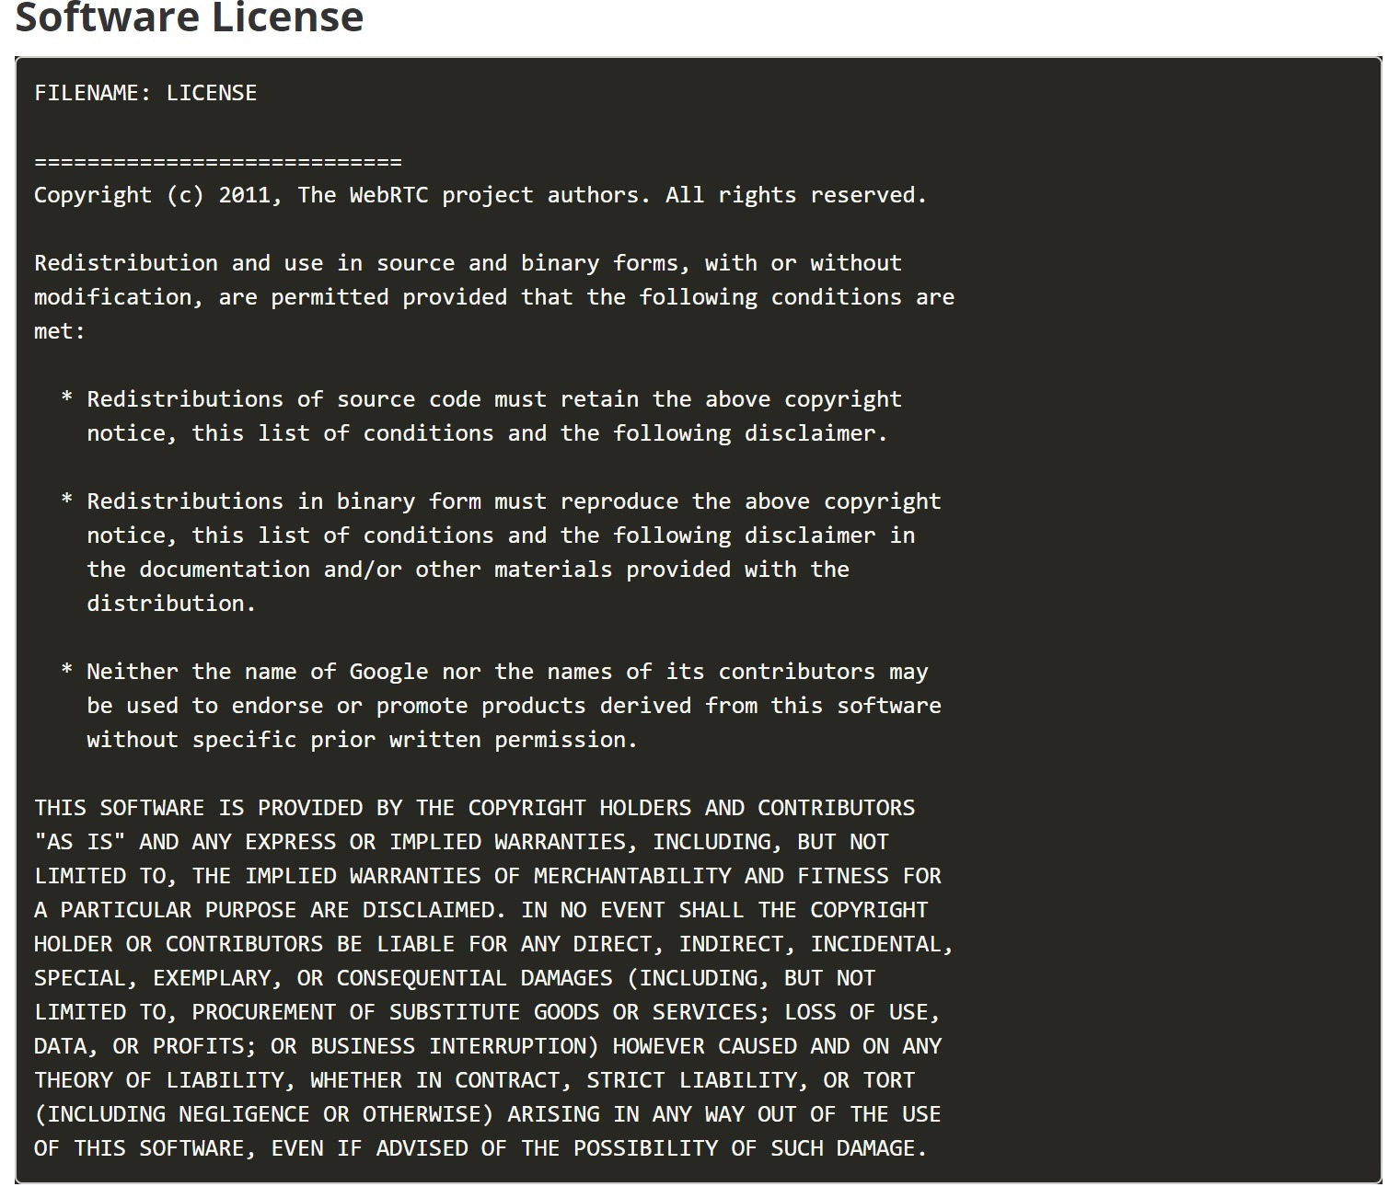

**WebRTC API’s**

|  |  |  |
| --- | --- | --- |
| Video/Text Chat API | Advantages | Disadvantages |
| Vidyo | * Platforms for mobile and desktop * Great Video Quality from good encoding * Possible for offline deployment * Text Chat | * WebRTC only works with plugin which may not work * Bad customer support * Bugs in the API * Pricing is dependent on minutes used. |
| Tokbox | * Can be used on multiple platforms * Free Trial * Text Chat | * Paid Support * Pay by minute |
| Twilio | * Has quick guides in python for SMS and chat * Supports chat, SMS and video * Messages can be encrypted | * Chat has a limit of storing 1000 messages per user * No free trial for SMS |